Re-Oligotrophication Over 20 years Contributed to Macrophyte Community Shifts and Recovery in the Upper Mississippi River

Running Title: Re-Oligotrophy Spurs Macrophyte Recovery

**DRAFT: Please do not cite or distribute without permission from authors, thanks**

Danelle M. Larson,
-U.S. Geological Survey, 2630 Fanta Reed Road, La Crosse, WI 54603;
e-mail: dmlarson@usgs.gov; 608-781-6350
ORCID: 0000-0001-6349-6267
*corresponding author

Mirkka Jones,
-Research Centre for Ecological Change, Organismal and Evolutionary Biology Research Programme, University of Helsinki, Helsinki, Finland
-Institute of Biotechnology, HILIFE Helsinki Institute of Life Science, University of Helsinki, Helsinki, Finland
e-mail: mirkka.jones@helsinki.fi
ORCID: 0000-0002-8157-8730

Benjamin Weigel,
- INRAE, EABX, 33612 Cestas, France
- Research Centre for Ecological Change, Organismal and Evolutionary Biology Research Programme, University of Helsinki, Helsinki, Finland
e-mail: benjamin.weigel@inrae.fr
ORCID: 0000-0003-2302-5529

Brian Gray,
-U.S. Geological Survey, 2630 Fanta Reed Road, La Crosse, WI 54603;
e-mail: brgray@usgs.gov
ORCID: 0000-0001-7682-9550

Otso Ovaskainen,
-Department of Biological and Environmental Science, University of Jyväskylä, Jyväskylä, Finland
- Research Centre for Ecological Change, Organismal and Evolutionary Biology Research Programme, University of Helsinki, Helsinki FI-00014, Finland
- Centre for Biodiversity Dynamics, Department of Biology, Norwegian University of Science and Technology, N-7491 Trondheim, Norway
e-mail: otso.t.ovaskainen@jyu.fi
ORCID: 0000-0001-9750-4421

Target journal: Global Change Biology
Review Disclaimer: This draft manuscript is distributed solely for purposes of scientific peer review. Its content is deliberative and pre-decisional, so it must not be disclosed or released by reviewers. Because the manuscript has not yet been approved for publication by the U.S. Geological Survey (USGS), it does not represent any official USGS finding or policy.

TABLE 1 The relevance of nine hypothesized covariates as environmental drivers of the aquatic macrophyte community on the UMR. Hypotheses are that of the authors with important input from many Mississippi River stakeholders and regional macrophyte experts at a “2021 macrophyte restoration workshop.” The public data sources are provided in table footnotes.
Covariate grouping | Covariate acronym | Covariate (measurement units) | Relevance for macrophytes
Hydrogeomorphology | DEPTH | Average water depth(m) at plot at time of macrophyte sampling | - Determines the dominant plant life form  - Metric of habitat heterogeneity at multiple spatiotemporal scales  - Limiting for submersed plants due to light interception that affects photosynthesis
Hydrogeomorphology | CONNECTIVITY | Index of hydrologic connectivity (%). Calculated as the percent of perimeter from a 50-m radius buffer that is aquatic. | - Influences local hydrology and flow patterns, wind fetch, water quality, and macrophyte dispersal  - Metric of habitat heterogeneity, floodplain complexity, and human alterations to geomorphology
Hydrogeomorphology | VELOCITY, | Water velocity (meters per second) | - Causes mechanical stress  - Limiting factor in river environments
Hydrogeomorphology | EXCEEDANCE | Low water depth (centimeter); specifically,water depth at the 75% exceeded discharge over the previous 40-year period. | - Signifies low water conditions that can stimulate reproduction and improve water clarity by consolidating suspended sediments  - Hypothesis: low water can be a catalyst for plant re-colonization and abundance
Water quality | logN^{,4} and logP^{3, 4} | Concentrations of total nitrogen and total phosphorus (milligrams per liter[mg/L]), log-transformed prior to modelling | - Provides essential macronutrients needed for plant growth and reproduction  - High nutrient status indicates eutrophy  - Hypothesis: nutrient reduction (“re-oligotrophy”) supports macrophyte recovery
Water quality | TSS³ | Total suspended solids (mg/L) | - Exponentially decreases light availability for photosynthesis.  - Excess TSS arises from agricultural runoff, sewage inputs, or shoreline and island erosion.  - Hypothesis: TSS reductions (re-oligotrophy) facilitates macrophyte recovery
Water quality | CHLOROPHYLL³ | Chlorophyll a concentration (microgram per liter); proxy for phytoplankton biomass | - Phytoplankton are superior competitors to macrophytes for nutrients and light  - High chlorophyll a indicates eutrophy  - Hypothesis: chlorophyll a reduction supports macrophyte recovery
Climate | TEMPERATURE³ | Water temperature (°Celsius) | - Affects macrophyte metabolic rates, reproductive cycles, nutrient leaching, and decay rates  - Causes mortality of heat-intolerant species  - Macrophyte sensitivity indicates a biological response to climatic changes

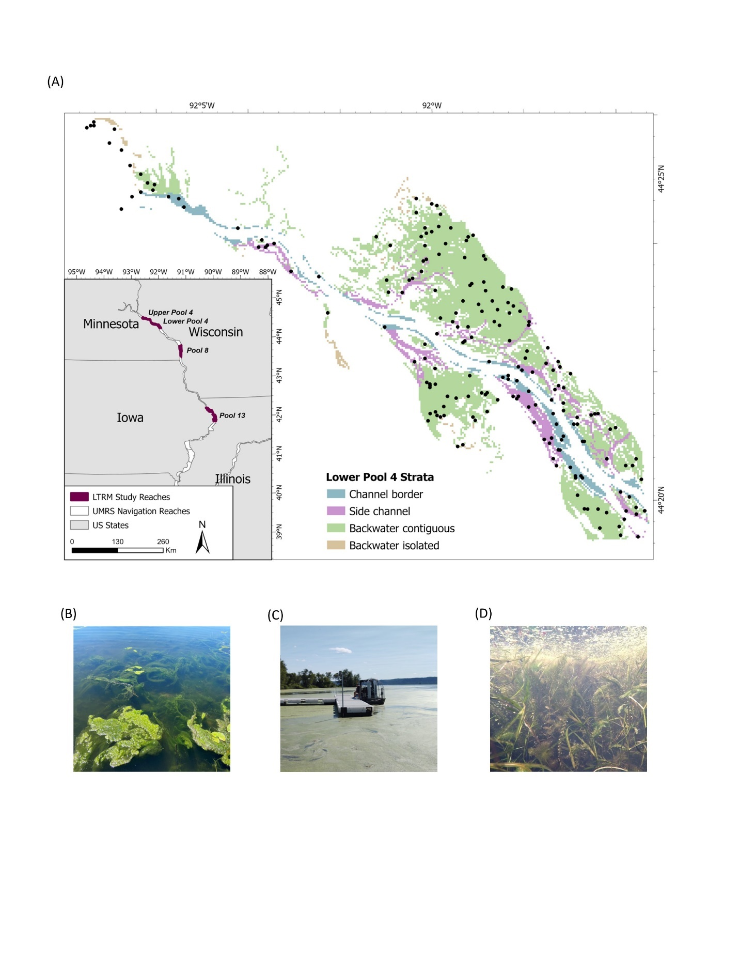
FIGURE 1 A map of the UMR showing (A) four study pools with long-term resource monitoring (LTRM) included in this study (“LTRM Study Reaches”), which span ~400 river km. Using Lower Pool 4 as an example, the map displays the four primary strata and examples of 450 macrophyte sampling plots (green dots) for a given year selected via a stratified random sampling design. The photographs show various macrophyte traits of “life form” on the river: (B) algae (several species of filamentous macroalgae); (C) free-floating plants (several species of duckweeds and water ferns); and (D) submersed plants. Map and photographs by Alicia Carhart and Shawn Giblin, used with permission.
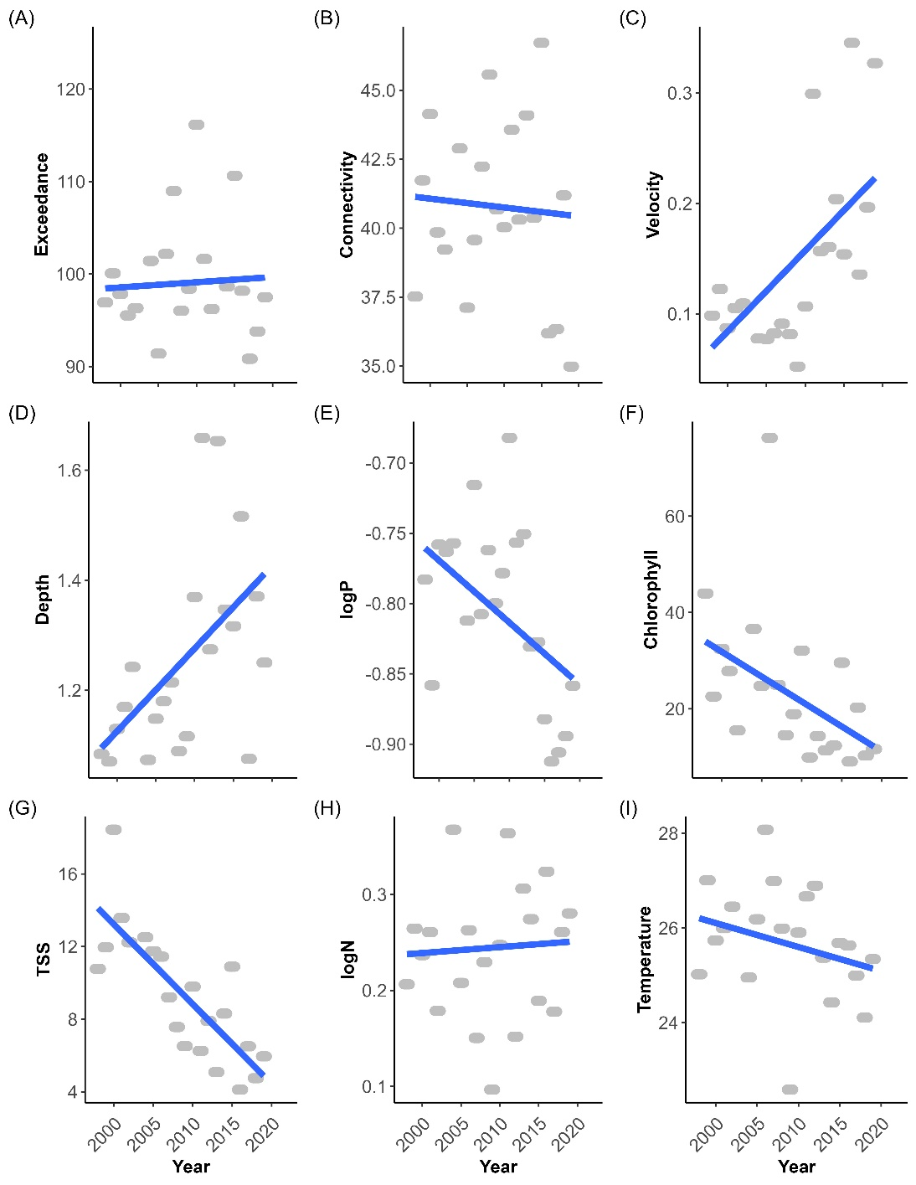

FIGURE 2 The environmental covariates at vegetated plots in Lower Pool 4 of the UMR show the mean trendlines (blue line) and the mean annual values collected in summer (gray dots) to highlight how environmental conditions changed over time. These nine environmental covariates were hypothesized to affect macrophytes (Table 1) and included multiple panels indicated in figures A–I: (A) exceedance, a measure of low water years (cm); (B) connectivity, an index of hydrologic connectivity (0–100% connected); (C) water velocity (m/s); (D) plot-averaged water depth during time of macrophyte sampling (meter); (E) total P concentration, log-transformed (mg/L); (F) total N concentration, log-transformed (mg/L); (G) chlorophyll a concentration (mg/L); (H) total suspended solids (mg/L); and (I) water temperature (°Celsius).

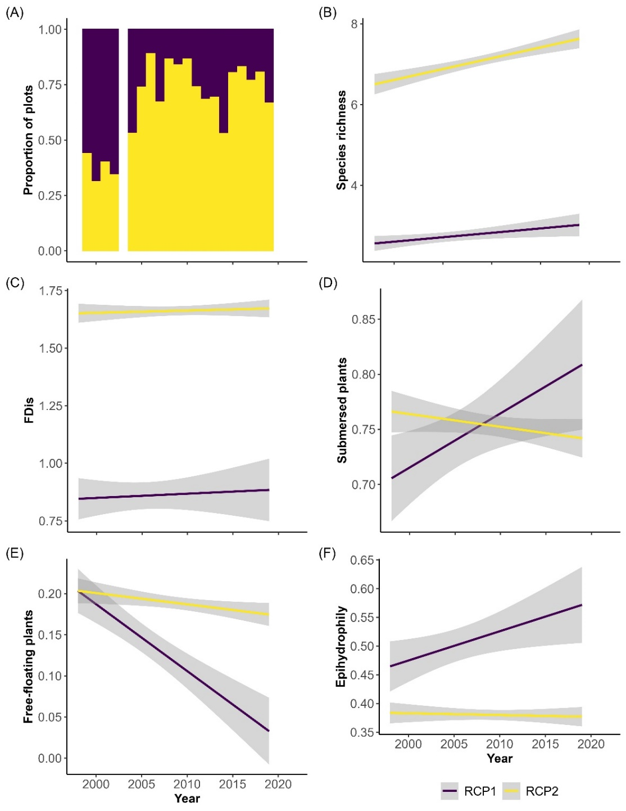
FIGURE 3 Time series of the relative extent of the taxonomic and functional changes from two macrophyte regions of common profile (RCP) from Lower Pool 4 of the UMR. The RCPs were defined using k-means partitioning and the Jaccard index with dissimilarity calculated for 2,028 vegetated plots. The y axes refer to (A) proportion of plots classified into each RCP each year, but note missing year 2003 because data were not collected; (B) species richness, or number of species; (C) functional diversity index (FDis) based on macrophyte traits; (D), prevalence of submersed plants; (E) prevalence of free-floating plants; and (F) prevalence of epihydrophilous plants.
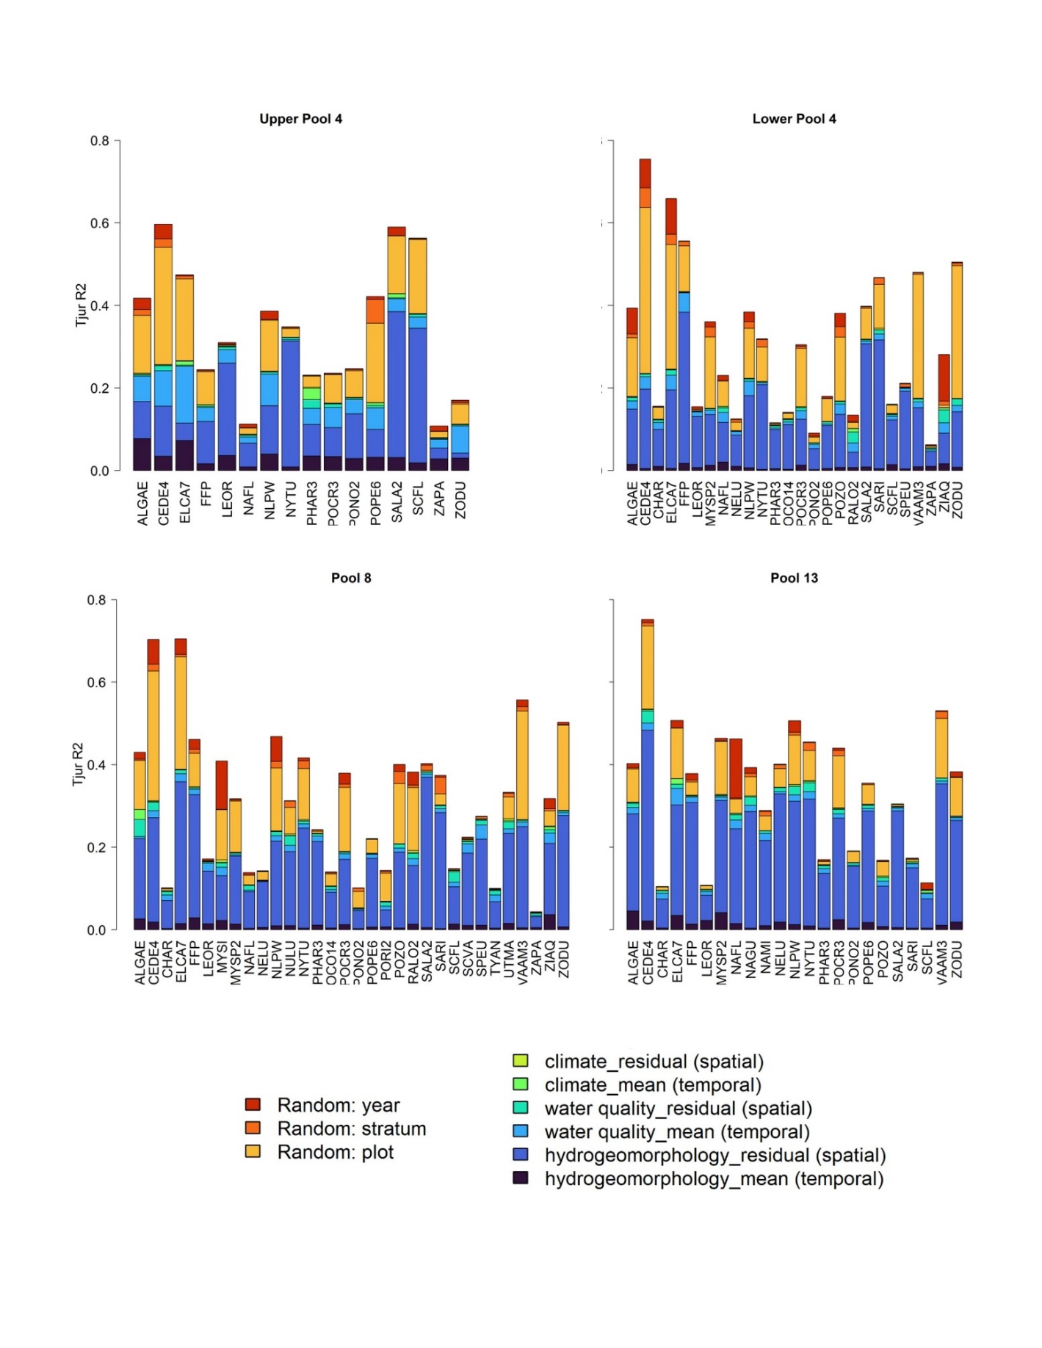

FIGURE 4 Graph shows variation (scaled by Tjur R²) in macrophyte occurrence distributions explained by spatiotemporal processes (represented by random effects, in reds and oranges) versus by the measured environmental covariates (hydrology, water quality, and climate represented in yellows, blues, and violet) in each of the four study pools in the UMR. The effects of each environmental covariate were modelled as a function of their annual mean (representing a temporal component of environmental variation) and their within-year residual from the annual mean (representing a spatial component of environmental variation). Each bar shows variation explained for each macrophyte species. The species codes on the x-axes are standards from the U.S. Department of Agriculture’s (USDA) Plants Database and Supplemental Table 1. Table 1 lists each environmental covariate grouped under hydrology, water quality, and climate.
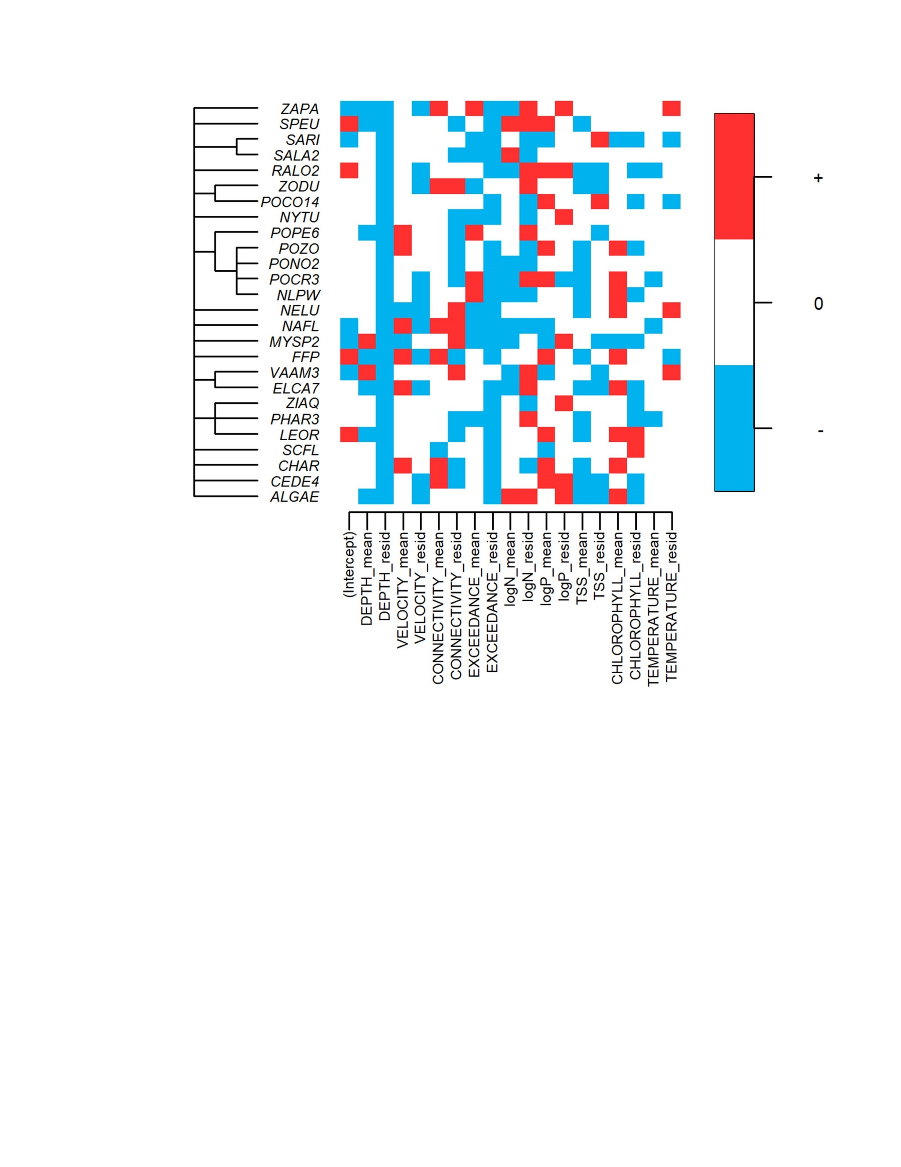
FIGURE 5 Diagram showing the relationships among macrophyte taxa (sorted as a taxonomic tree on the left) and their taxonomically-structured responses to environmental covariates representing hydrology, water quality, and climate in Lower Pool 4 of the UMR. Positive and negative responses (with statistical support of >90% posterior probability) were illustrated in red and blue, respectively. The species’ environmental responses were modelled to separate the temporal and spatial variations in environmental conditions. Annual covariate means per pool (“COVARIATE_mean”’) represented the temporal variation in each environmental covariate across 22 years, and their within-year residuals (“COVARIATE_residual”) represented spatial variation in environmental conditions within years. Negative β for the residuals indicates that macrophytes were responding negatively to high values of the covariate. Positive β with >90% posterior probability for the annual covariate mean indicates that aquatic plant occurrences were greater in years with higher values for the environmental covariates. The macrophyte species codes are further described in Supplemental Table 1. Similar plots for the other study pools are in Supplemental Figure 7.

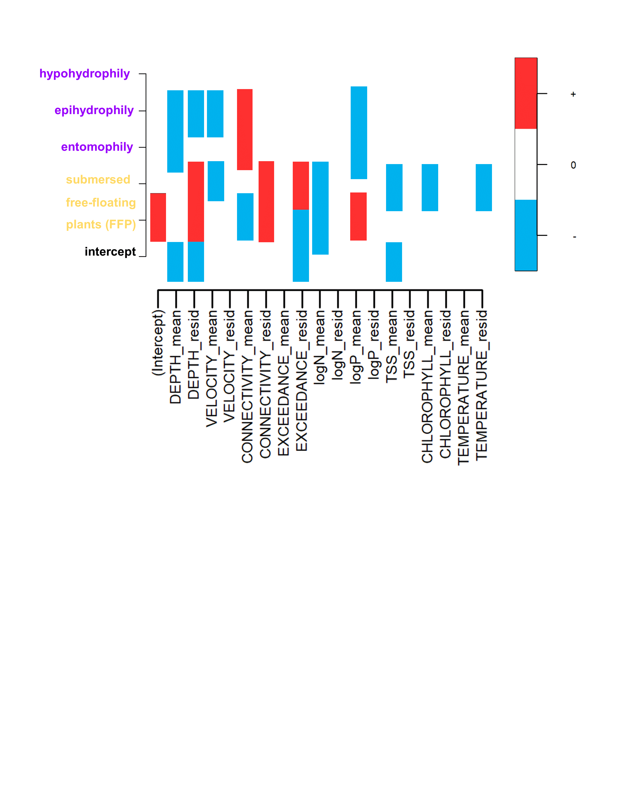

FIGURE 6 Macrophyte trait responses to covariates of hydrology, water quality, and climate combined from four study pools of the UMR. The macrophyte trait-environmental responses are separated into temporal and spatial influence; specifically, covariate means (‘COVARIATE_mean’) represented the temporal variation across 22 years and the residuals (‘COVARIATE_resid’) represented the spatial variation within years. Positive and negative responses of each trait (with statistical support of >90% posterior probability) are illustrated by the red and blue colors, respectively. Traits include life form (yellow; levels of free-floating plants (FFP) and submersed) and pollination mode (violet; levels of hypohydrophily, epihydrophily, and entomophily).

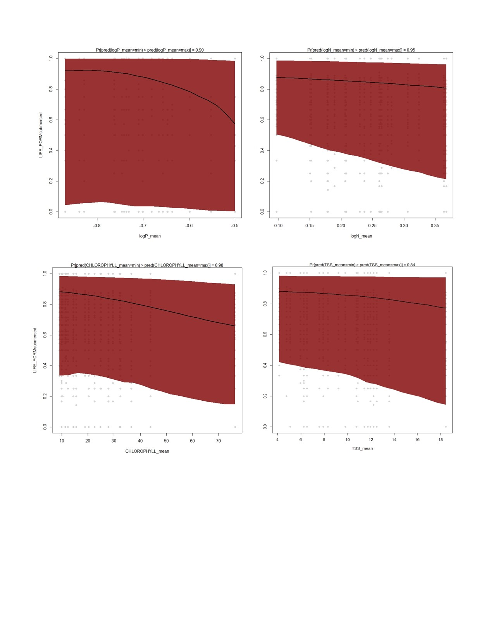
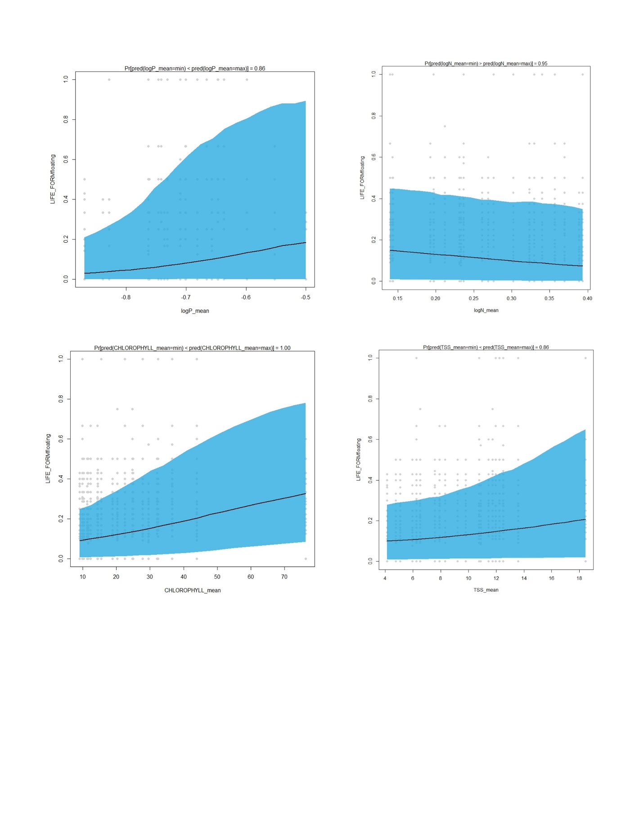
FIGURE 7 Macrophyte trait responses to mean water quality conditions from Lower Pool 4 of the UMR. The traits shown are life forms as submersed plants (blue) or free-floating plants (red). All covariates shown have >90% posterior probability that life form is influenced by the water quality covariates: (A) total phosphorus concentration, log-transformed (mg/L); (B) total nitrogen concentration, log-transformed (mg/L); (C) chlorophyll a concentration (mg/L); (D) total suspended solids (mg/L).

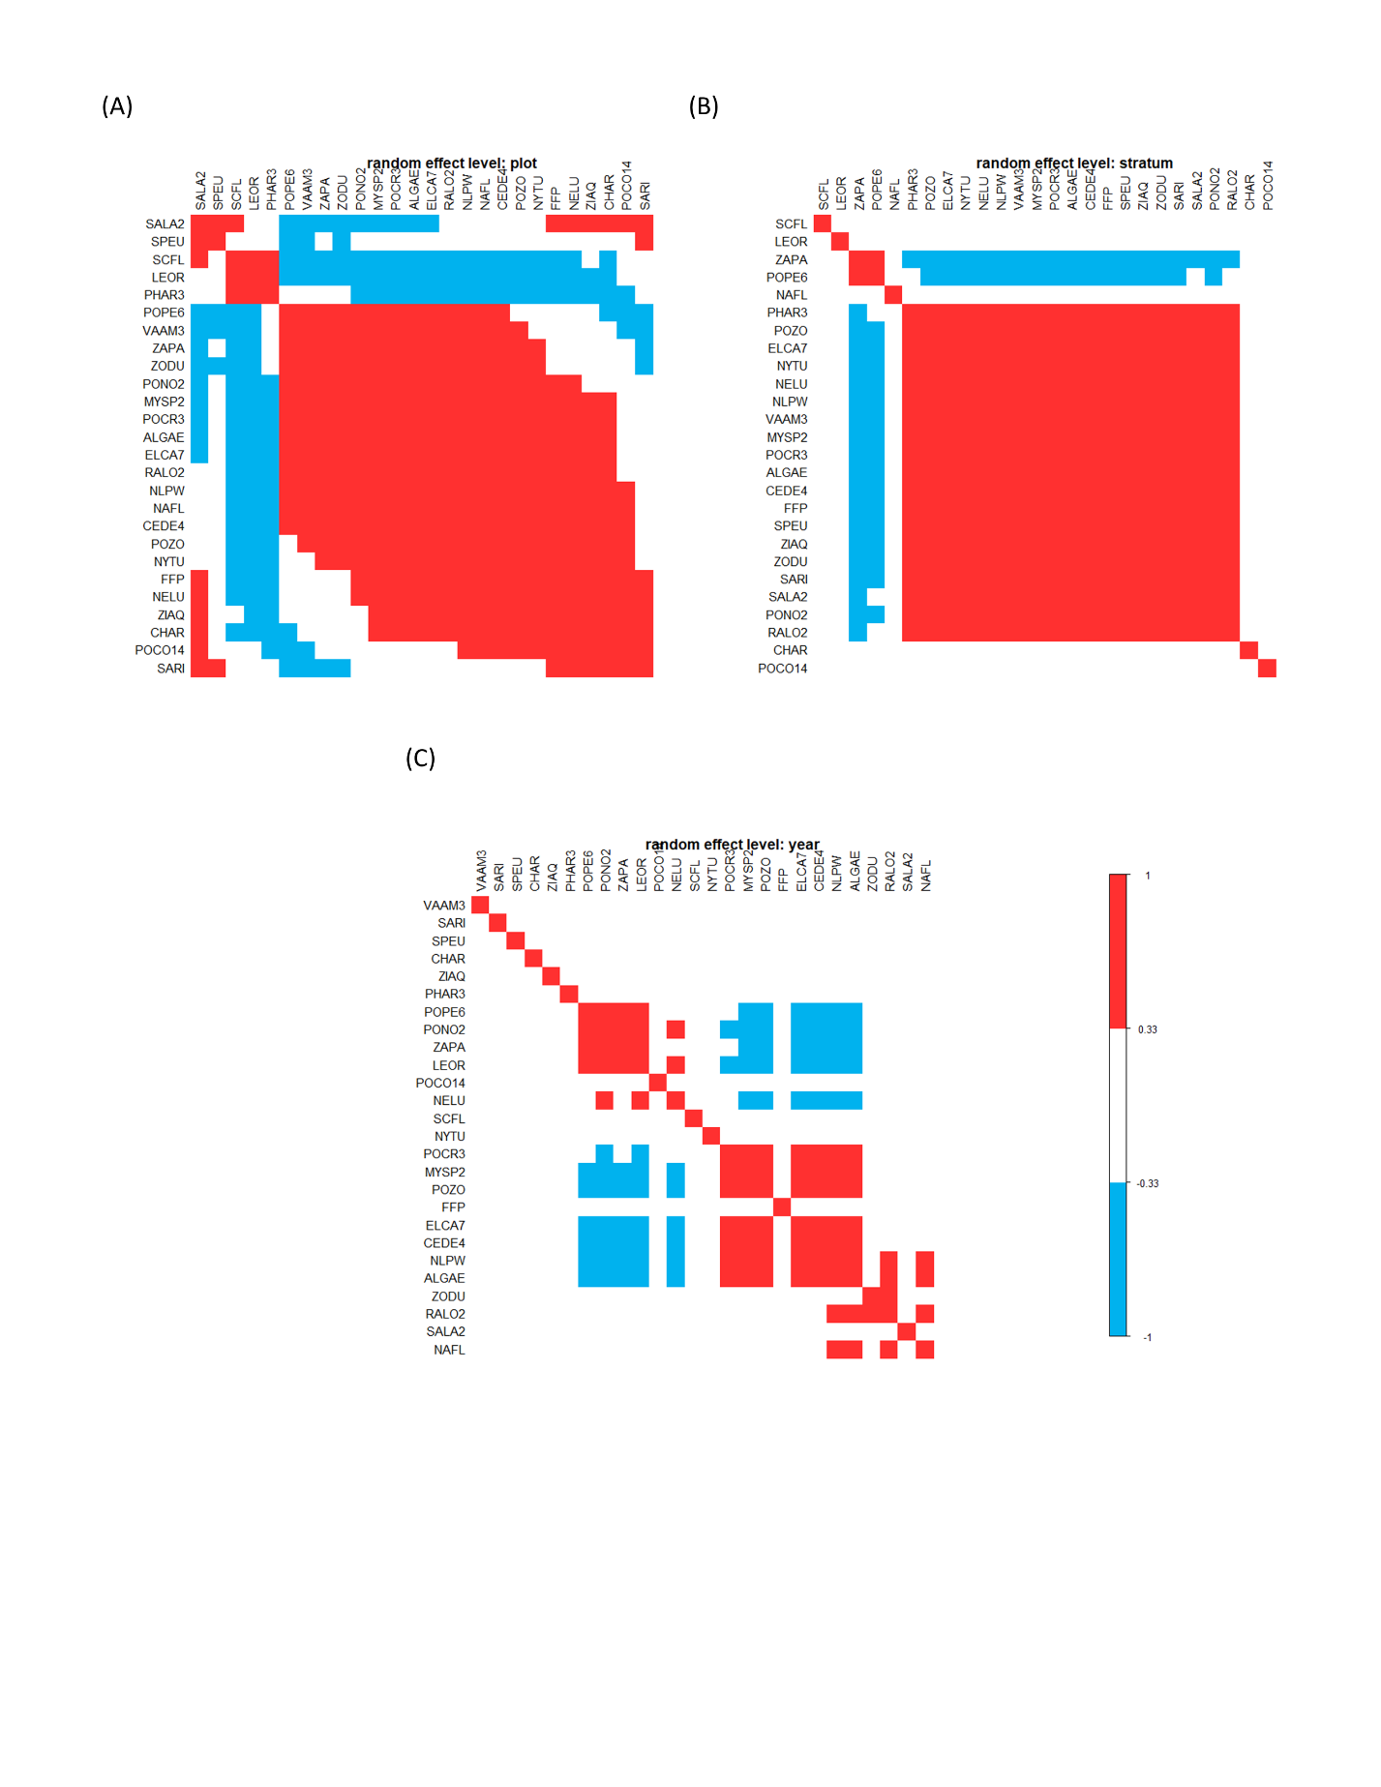

FIGURE 8 Figures showing residual associations among 26 macrophyte species at three spatiotemporal scales within Lower Pool 4, UMR. The macrophyte species codes are standards from the USDA Plants Database and further described in Supplemental Table 1. The associations are graphed for the plot-level (A), stratum-level (B), and year-level (C). Pairs of species illustrated by red and blue show positive and negative associations, respectively (with statistical support of >90% posterior probability). Residual associations may be interpreted as species co-occurrences after accounting for their environmental niches.

SUPPLEMENTAL TABLES AND FIGURES
SUPPLEMENTAL TABLE 1 Aquatic macrophyte species found throughout the UMR. Data were retrieved on 20 March 2021 from https://umesc.usgs.gov/data_library/vegetation/srs/veg_srs_1_query.shtml. We list 71 aquatic macrophyte species over the period of record (1998–2023) in Pools 4, 8, and 13 of the UMR. Species’ codes are from the USDA Plants Database, and taxonomic authority was used from the Integrated Taxonomic Information System (ITIS) in 2024. Life form includes submersed (“S”), emersed (“E”), rooted floating-leaved (“F”), nonrooted floating-leaved (“N”), and filamentous algae (“A”). Pollination mode includes entomophily (by insects), hypohydrophily (under the water’s surface), epihydrophily (on the water’s surface), or N/A (not available because algae does not pollinate). Native status includes either native (“N”) or not native/invasive (“NN/I”) to the UMR Basin. USDA Wetland status includes obligate wetland (“OBL”) and facultative wetland (“FACW”) for the Midwest Region of the United States. Species are listed in order of most common occurrences as of 2025.
Species’ code | Common names | Family | Scientific name | Life form | Pollination mode | Native status | USDA wetland status (Midwest region)
CEDE4 | coontail | Ceratophyllaceae | Ceratophyllum demersum L. | S | Hypohydrophily | N | OBL
ELCA7 | Canadian waterweed | Hydrocharitaceae | Elodea canadensis Michx. | S | Epihydrophily | N | OBL
VAAM3 | watercelery, wild celery | Hydrocharitaceae | Vallisneria americana Michx. | S | Epihydrophily | N | OBL
LEMI3 (FFP) | small duckweed | Lemnaceae | Lemna minor L. | N | Entomophily | N | OBL
ZODU | water stargrass, grassleaf mudplantain | Pontederiaceae | Heteranthera dubia (Jacq.) MacM. | S | Epihydrophily | N | OBL
NLPW | narrow-leaf pondweed | Potamogetonaceae | Potamogeton foliosus Raf. or  Potamogeton pusillus L. | S | Epihydrophily | N | OBL
ALGA | filamentous algae (not speciated) | algae, filamentous | Filamentous algae | A | No pollination mode | N | OBL
POPE6 | sago pondweed | Potamogetonaceae | Stuckenia pectinata (L.) Börner | S | Hypohydrophily | N | OBL
SPPO (FFP) | big duckweed | Lemnaceae | Spirodela polyrrhiza (L.) Schleid. | N | Entomophily | N | OBL
NYTU | white waterlily | Nymphaeaceae | Nymphaea odorata Ait. spp tuberosa (Paine) Wiersma & Hellquist | F | Entomophily | N | OBL
MYSP2 | Eurasian watermilfoil | Haloragaceae | Myriophyllum spicatum L. | S | Epihydrophily | NN/I | OBL
POCR3 | curly-leaved pondweed | Potamogetonaceae | Potamogeton crispus L. | S | Epihydrophily | NN/I | OBL
NELU | lotus, American lotus | Nelumbonaceae | Nelumbo lutea Willd. | F | Entomophily | N | OBL
POZO | flatstem pondweed | Potamogetonaceae | Potamogeton zosteriformis Fern. | S | Epihydrophily | N | OBL
WOCO  (FFP) | Columbian watermeal | Lemnaceae | Wolffia columbiana Karst. | N | Entomophily | N | OBL
SALA2 | broadleaf arrowhead | Alismataceae | Sagittaria latifolia Willd. | E | Entomophily | N | OBL
SARI | sessilefruit arrowhead | Alismataceae | Sagittaria rigida Pursh. | E | Entomophily | N | OBL
PONO2 | longleaf pondweed | Potamogetonaceae | Potamogeton nodosus Poir. | S | Epihydrophily | N | OBL
ZIAQ | wild rice | Poaceae | Zizania spp. (genetics unknown as of 2024) | E | Epihydrophily | N | OBL
NAFL | nodding waternymph | Najadaceae | Najas flexilis (Willd.) Rostk. & Schmidt | S | Hypohydrophily | N | OBL
LETR (FFP) | star duckweed | Lemnaceae | Lemna trisulca L. | N | Entomophily | N | OBL
SPEU | giant burreed | Sparganiaceae | Sparganium eurycarpum Engelm. ex-Gray | E | Epihydrophily | N | OBL
SCFL | river bulrush | Cyperaceae | Bolboschoenus fluviatilis Torr. Soják | E | Epihydrophily | N | OBL
PHAR3 | reed canarygrass | Poaceae | Phalaris arundinacea L. | E | Entomophily | NN/I | FACW
NAGU | southern waternymph | Najadaceae | Najas guadalupensis (Spreng.) Magnus | S | Hypohydrophily | N | OBL
UTMA | common bladderwort | Lentibulariaceae | Utricularia vulgaris ssp. macrorhiza | S | Entomophily | N | OBL
RALO2 | longbeak buttercup | Ranunculaceae | Ranunculus aquatilis var. diffusus | S | Entomophily | N | OBL
LEOR | rice cutgrass | Poaceae | Leersia oryzoides (L.) Sw. | E | Epihydrophily | N | OBL
MYSI | northern watermilfoil | Haloragaceae | Myriophyllum sibiricum Komarov | S | Epihydrophily | N | OBL
CHAR | Chara (macro-algae), muskgrass | Characeae | Chara spp. | S | No pollination mode | N | OBL
NAMI | brittle naiad | Hydrocharitaceae | Najas minor All. | S | Hypohydrophily | NN/I | OBL
SCVA | softstem bulrush | Cyperaceae | Schoenoplectus tabernaemontani (K.C. Gmel.) Palla | E | Epihydrophily | N | OBL
POCO14 | pickerelweed | Pontederiaceae | Pontederia cordata L. | E | Entomophily | N | OBL
ZAPA | horned pondweed | Zannichelliaceae | Zannichellia palustris L. | S | Hypohydrophily | N | OBL
NULU | yellow pond lily | Nymphaeaceae | Nuphar lutea (L.) Sm. | F | Entomophily | N | OBL
PORI2 | Richardson's pondweed | Potamogetonaceae | Potamogeton richardsonii (Benn.) Rydb. | S | Epihydrophily | N | OBL
BUUM | Flowering rush | Butomaceae | Butomus umbellatus L. | E | entomophily | NN/I | OBL
ECCR | Barnyard grass | Poacae | Echinochloa crus-galli (L.) P. Beauv. | E | entomophily | NN/I | OBL
LYSA2 | purple loosestrife | Lythraceae | Lythrum salicaria L. | E | entomophily | NN/I | OBL
POAM8 | water knotweed | Polygonaceae | Polygonum amphibium L. | E | entomophily | N | OBL
POHY2 | Swamp smartweed | Polygonaceae | Polygonum hydropiperoides Michx. | E | entomophily | N | OBL
SANI | Black willow | Salicaceae | Salix nigra Marshall | E | entomophily | N | FACW/OBL
TYAN | Narrowleaf cattail | Typhaceae | Typha angustifolia L. | E | entomophily | NN/I | OBL
TYLA | Broadleaf cattail | Typhaceae | Typha latifolia L. | E | entomophily | N | OBL

SUPPLEMENTAL TABLE 2 The beta parameter estimates for macrophyte species’ responses to each model covariate per pool. Covariates were modeled separately as each pool’s annual mean (“COVARIATE_mean”), which indicates temporal variation through 22 years, and the annual residual (“COVARIATE_residual”), which indicates the spatial variation within years.
Covariate grouping | Covariate |  | Beta estimate
 |  | Upper Pool 4 | Lower Pool 4 | Pool 8 | Pool 13
 | (Intercept) | 0.54 | 0.06 | 0.14 | 0.14
Hydrogeomorphology | AVGDEPTH_mean | 0.13 | 0.14 | 0.08 | 0.08
Hydrogeomorphology | AVGDEPTH _residual | 0.56 | 0.13 | 0.07 | 0.07
Hydrogeomorphology | VELOCITY_mean | 0.58 | 0.08 | 0.16 | 0.14
Hydrogeomorphology | VELOCITY _ residual | 0.23 | 0.16 | 0.19 | 0.18
Hydrogeomorphology | CONNECTIVITY_ mean | 0.42 | 0.12 | 0.11 | 0.11
Hydrogeomorphology | CONNECTIVITY _ residual | 0.1 | 0.12 | 0.21 | 0.22
Hydrogeomorphology | EXCEEDANCE_ mean | 0.25 | 0.12 | 0.08 | 0.08
Hydrogeomorphology | EXCEEDANCE _ residual | 0.15 | 0.34 | 0.06 | 0.06
Water quality | logN_ mean | 0.41 | 0.31 | 0.04 | 0.04
Water quality | logN_ residual | 0.21 | 0.06 | 0.14 | 0.14
Water quality | logP_ mean | 0.66 | 0.05 | 0.04 | 0.04
Water quality | logP_ residual | 0.1 | 0.06 | 0.05 | 0.05
Water quality | TSS_ mean | 0.27 | 0.08 | 0.28 | 0.28
Water quality | TSS_ residual | 0.19 | 0.12 | 0.13 | 0.13
Water quality | CHLOROPHYLL_ mean | 0.51 | 0.12 | 0.13 | 0.13
Water quality | CHLOROPHYLL _ residual | 0.14 | 0.03 | 0.09 | 0.08
Climate | TEMPERATURE_ mean | 0.14 | 0.07 | 0.16 | 0.16
Climate | TEMPERATURE _ residual | 0.2 | 0.12 | 0.16 | 0.16

SUPPLEMENTAL TABLE 3 The beta estimates for each macrophyte species’ responses to covariate grouping per pool. Covariates groupings were modeled separately as each pool’s annual mean, which indicates temporal variation through 22 years, and the annual residual, which indicates spatial variation.

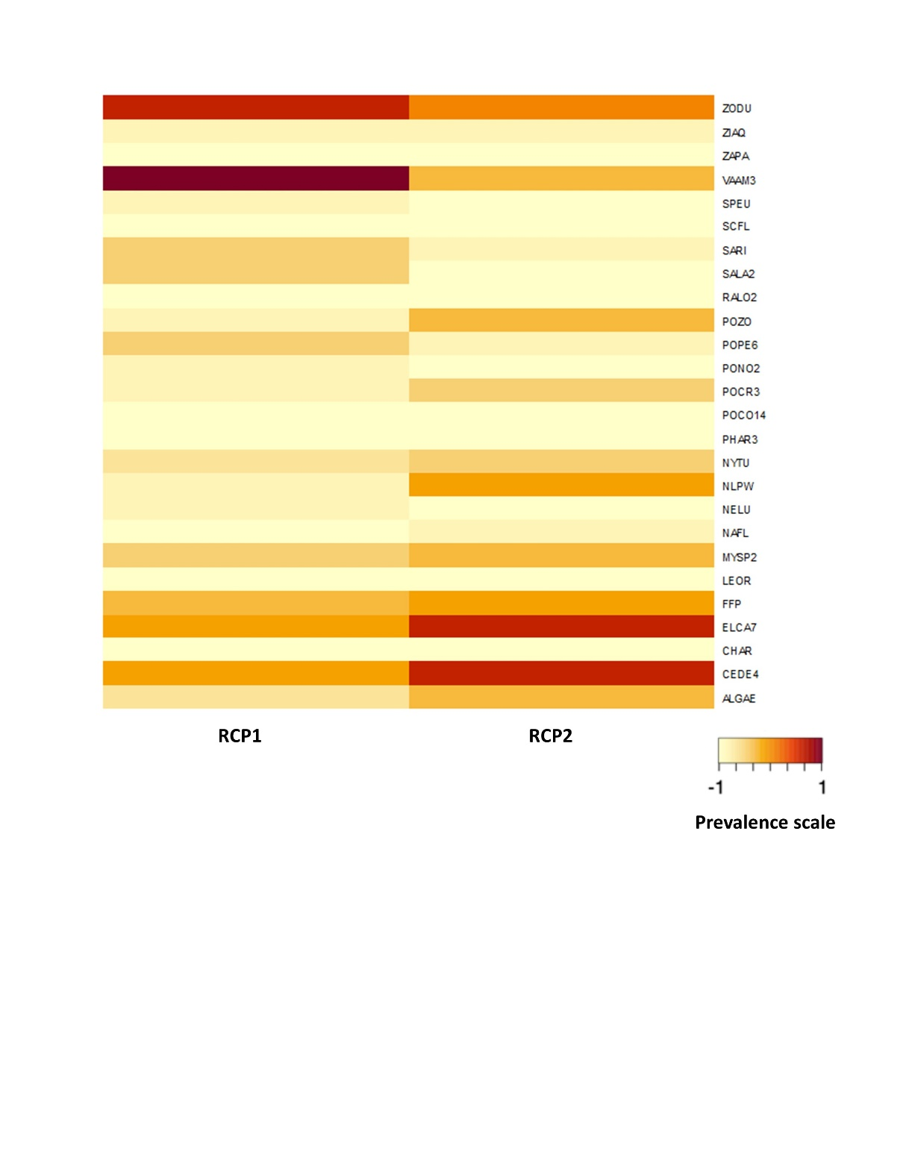

SUPPLEMENTAL FIGURE 1 Figure showing mean scaled (−1 to 1) prevalence of macrophyte species in the UMR (Upper Pool 4, Lower Pool 4, Pool 8, and Pool 13) divided into RCP1 and RCP2. Darker shades and greater prevalence values indicate relatively high prevalence of the species. Full species information is found in Supplemental Table 1.

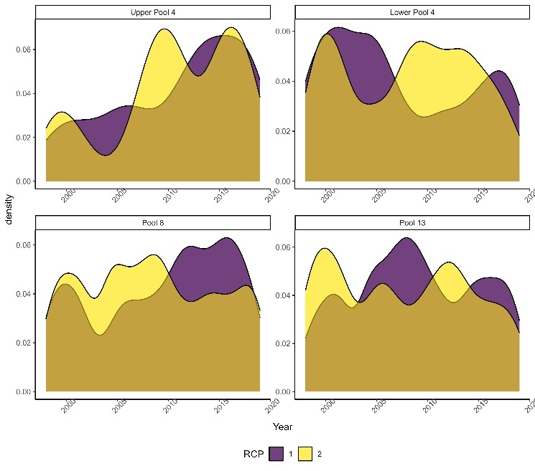
SUPPLEMENTAL FIGURE 2 Temporal shifts for the RCP of four study pools of the UMR. from years 1998–2019. The RCP are based on species composition and relative abundance of 35 aquatic macrophytes. RCP1 is characterized by a few pioneering plant species like wild celery Vallisneria americana L. (VAAM3), while RCP2 is characterized by greater species richness and relative plant prevalence.

7a – Upper Pool 4
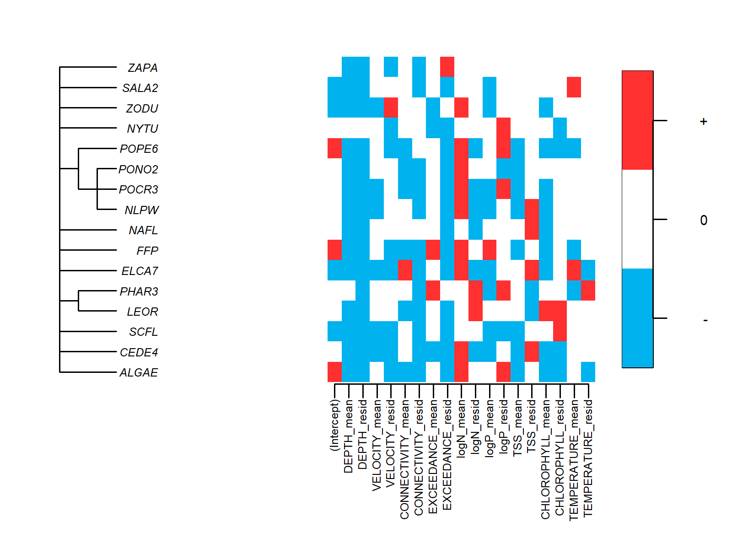

7b – Lower Pool 4
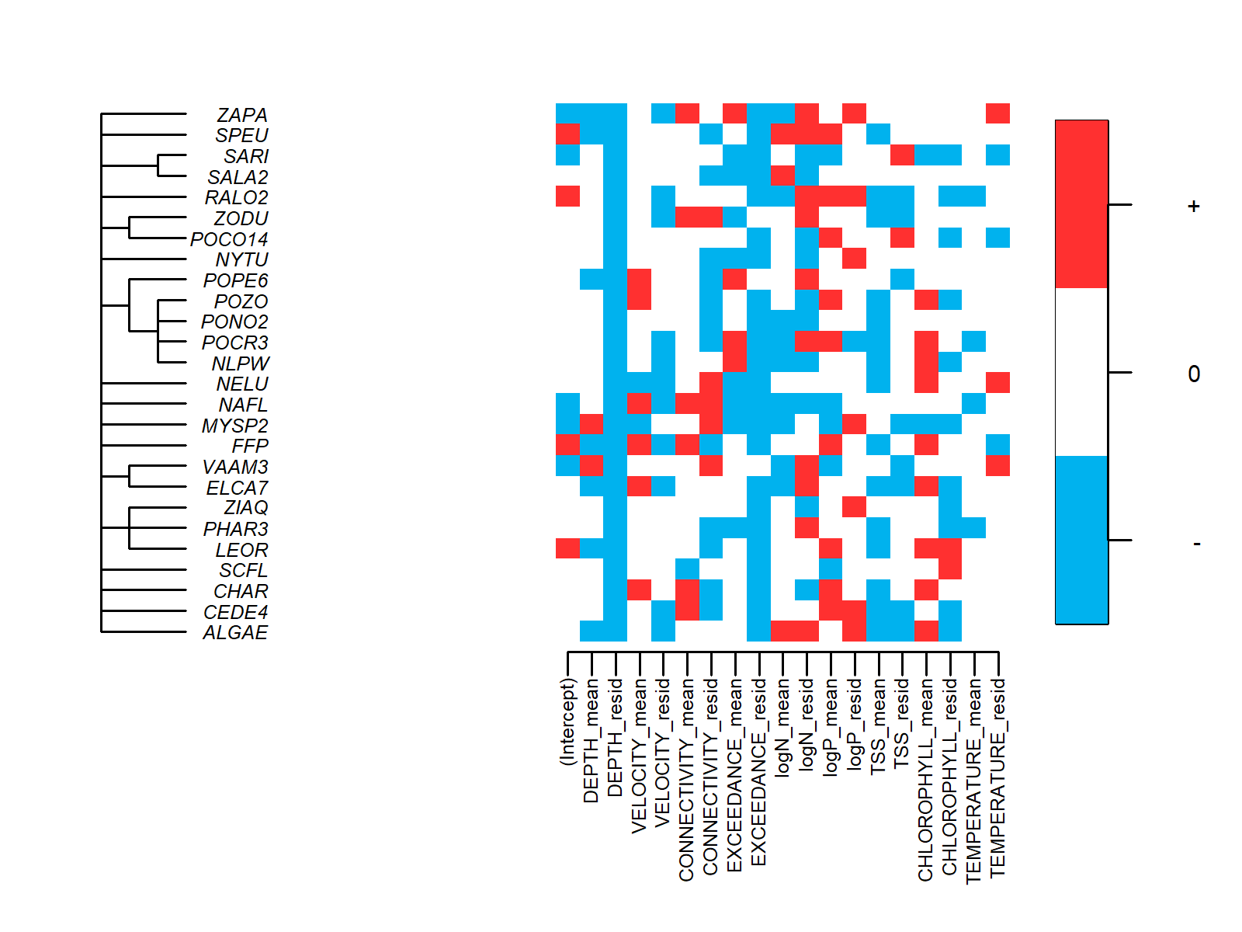

7c – Pool 8
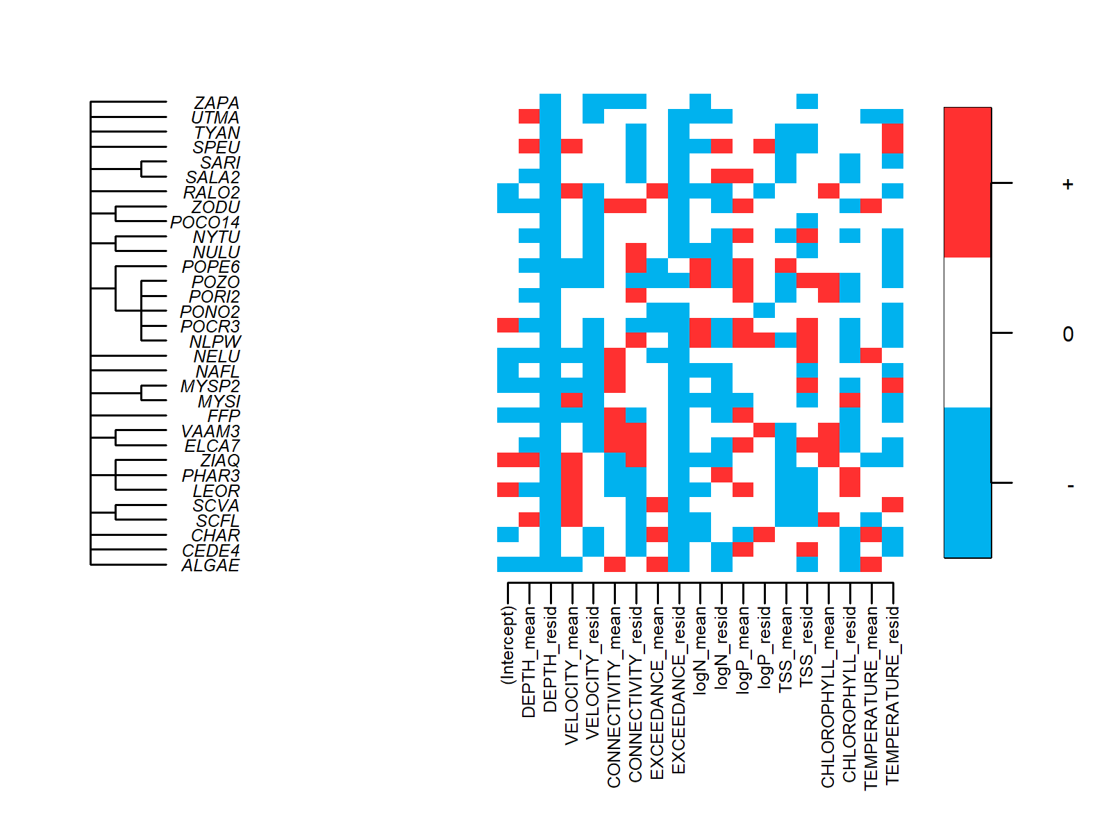

7d – Pool 13
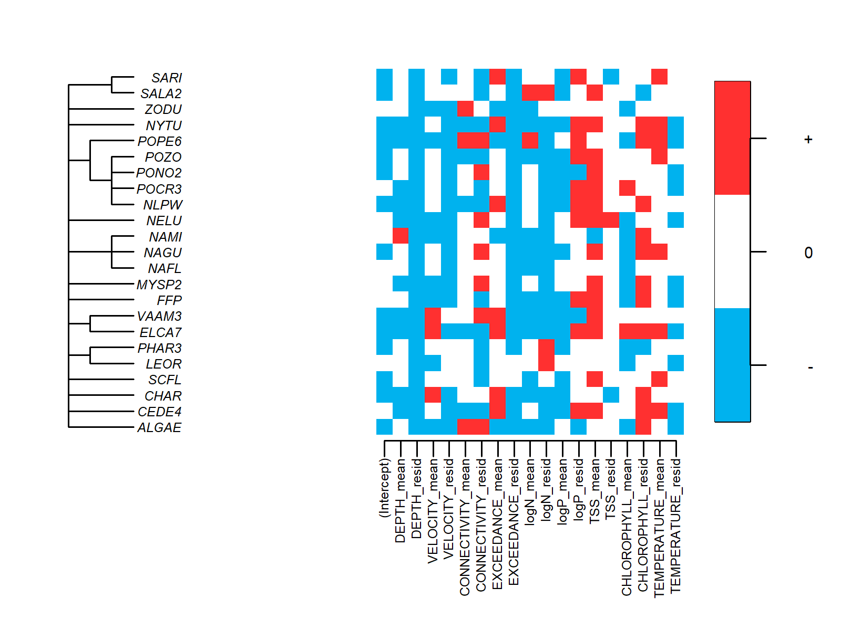
SUPPLEMENTAL FIGURE 3 The relationships among macrophyte taxa (taxonomic tree on the left) and their taxonomically structured responses to environmental covariates representing hydrology, water quality, and climate in four pools of the UMR. Positive and negative responses (with statistical support of >90% posterior probability) were illustrated by the red and blue color, respectively. The species’ environmental responses were modelled to separate the temporal and spatial variations in environmental conditions; specifically, annual covariate means per pool (“covariate_m”) represented the temporal variation in each environmental covariate across 22 years and their within-year residuals (“covariate_r”) represented spatial variation in environmental conditions within years. Positive β with >90% posterior probability for the annual covariate means indicates that aquatic plant occurrences were greater in years with higher values for the environmental covariates. The macrophyte species codes on the phylogenetic tree are standards from the USDA Plants Database and are further described in Supplemental Table 2.

SUPPLEMENTAL FIGURE 4 Marginal mean effects plots of the water quality covariates on macrophyte species richness in each study pool. All covariates had >90% posterior probability, which is the probability of the predicted species richness values to be either smaller or larger at minimum and maximum environmental covariates. CI not shown.

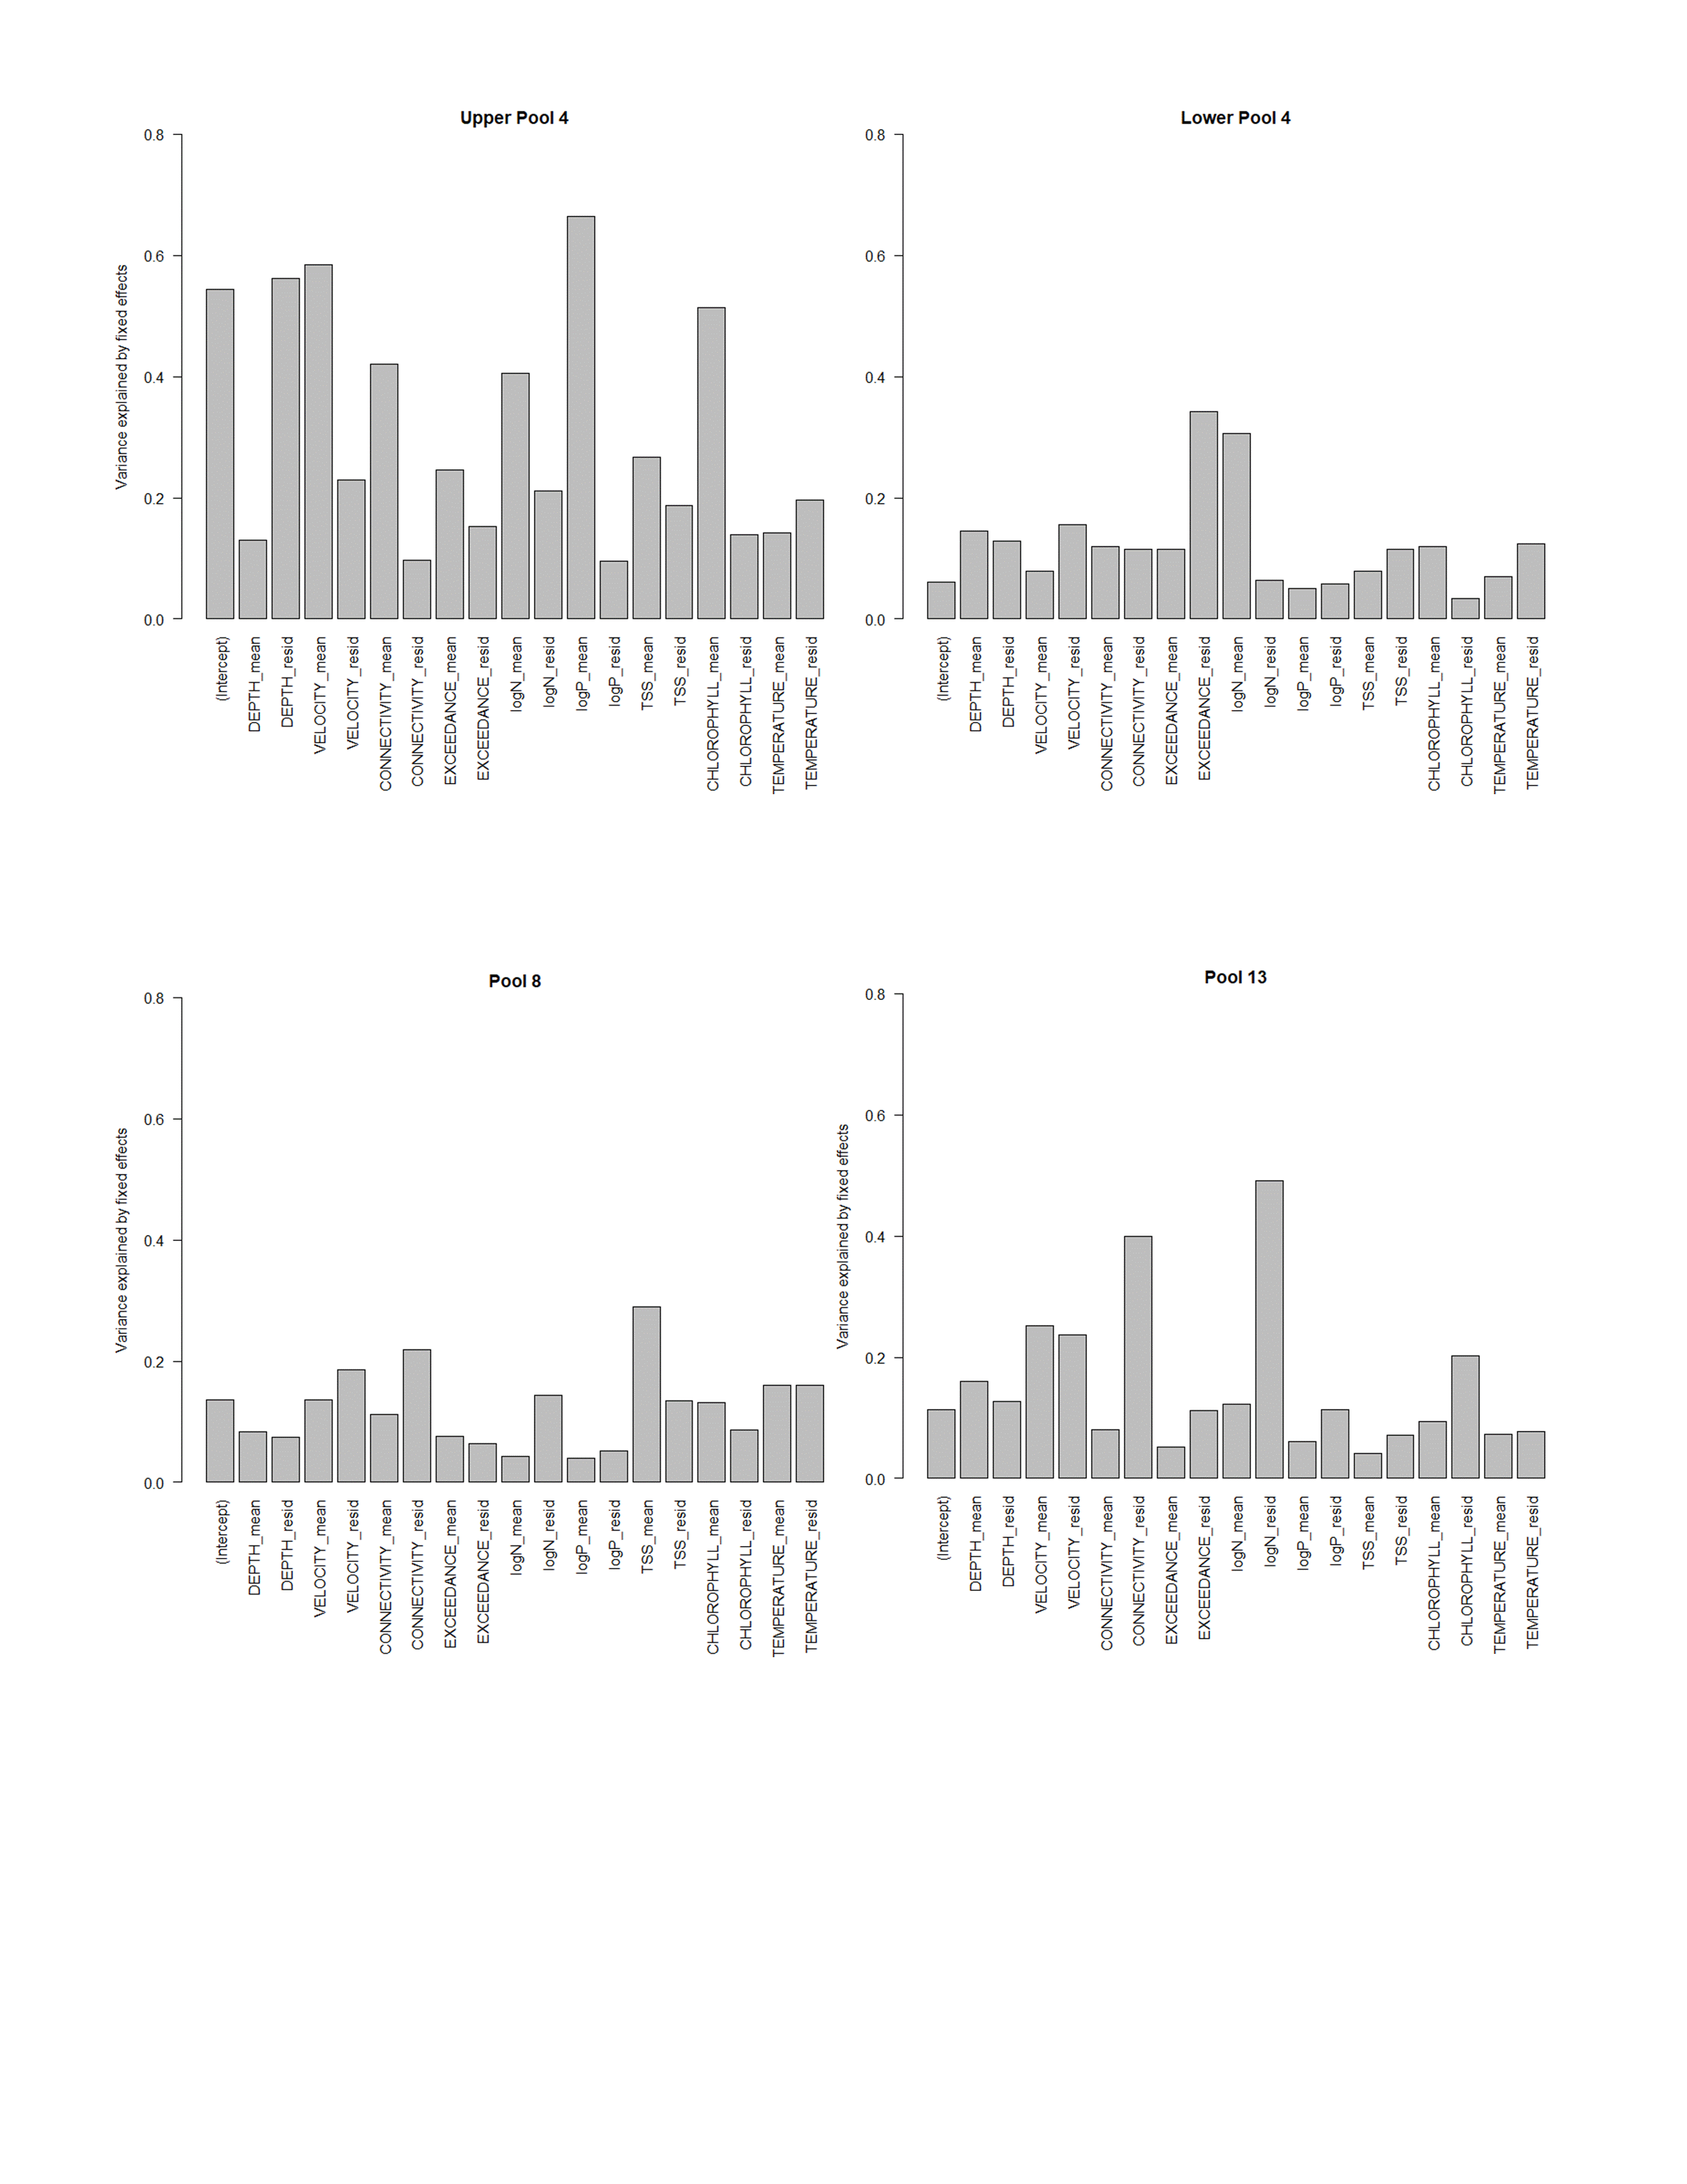
Supplemental Figure 5 The amount of total variation explained by each fixed effect, according to the modelled traits of life form and pollination mode. The macrophyte trait-environmental responses are separated into temporal and spatial influence; specifically, covariate means (‘COVARIATE_mean’) represented the temporal variation across 22 years and the residuals (‘COVARIATE_residual’) represented the spatial variation within years. Positive and negative responses of each trait (with statistical support of >90% posterior probability) are illustrated by the red and blue colors, respectively. Traits include life form (yellow; levels of free-floating and submersed) and pollination mode (violet; levels of hypohydrophily, epihydrophily, and entomophily).

Long-Term Resource Monitoring Program - SRS Vegetation Data Query (usgs.gov)
U.S. Army Corps of Engineers’ Upper Mississippi River Restoration Program Long -Term Resource Monitoring element 2010/11 Level 3 Aquatic Areas dataset (https://doi.org/10.5066/F7Z89BMP)
Upper Midwest Environmental Sciences Center - Water Quality Database Browser (usgs.gov)
Missing data were interpolated with >93% prediction accuracy; Larson et al. (2023)
James Rogala, 2019, Water depth at the 75% exceeded discharge condition for the Upper Mississippi River System (Mississippi River): U.S. Geological Survey data release, https://doi.org/10.5066/P92PSPHG.

